EXP NO 10 Develop an application to change the font and color of

the text and display toast message when the user presses the button.

AIM:
To develop an Android application that allows the user to change the font and color of text displayed on the screen and display a Toast message when a button is pressed.

ALGORITHM:
- Initialize the Android Application:
  - Set up a new Android project in Android Studio.
  - Create a MainActivity Java file for the main screen of the application.
- Design the User Interface (UI):
  - In the XML layout file, add the following UI components:

TextView: For displaying the text whose font and color will be changed.

Button: To trigger the change in font and color, and show a Toast message.

Spinner or Color Picker: To let the user choose a color (optional, or a simple button for a predefined color change).

RadioButtons or a Dropdown Menu to select different font styles (optional).
- Declare Variables:
  - Create references for the TextView, Button, Color Picker (if used), and Radio Buttons (if used to change font style).
  - Define variables for the font style, color, and the message to display in the Toast.
- Set Event Listener for the Button:
  - Set an OnClickListener for the Button.
  - Inside the onClick() method, write the logic to:


Change the font of the TextView based on the selected font style. Change the color of the TextView based on the selected color.

Display a Toast message indicating the action has been performed.

- Implement Font Style Changes:
  - Change the TextView’s font using setTypeface() to apply a selected font style (e.g., bold, italic).
  - You can either use predefined styles (like Typeface.BOLD or Typeface.ITALIC) or let the user choose from a list of font styles.
- Implement Color Change:
  - Change the TextView’s text color by using the setTextColor() method and applying the selected color (e.g., Color.RED, Color.BLUE, or a color from the Color Picker).
  - If using a color picker or dropdown, get the selected color and set it on the TextView.
- Show Toast Message:
  - Display a Toast message to the user when the button is clicked, informing them that the text style or color has changed. You can also show a message like &quot;Font and color changed!&quot; or any other appropriate message.
- End the Operation:
  - After the changes are made, the application will display the updated TextView with the new font and color, and the Toast message will appear to provide feedback.

Code:
ACTIVITY_MAIN.XML
<?xml version="1.0" encoding="utf-8"?>
<LinearLayout xmlns:android="http://schemas.android.com/apk/res/android" android:orientation="vertical"
android:gravity="center" android:padding="20dp" android:layout_width="match_parent" android:layout_height="match_parent">

<TextView android:id="@+id/textView" android:text="Hello Android" android:textSize="20sp" android:textColor="#000000"
android:layout_marginBottom="20dp" android:layout_width="wrap_content" android:layout_height="wrap_content"/>

<Button
android:id="@+id/btnColor" android:text="Change Color" android:layout_width="match_parent" android:layout_height="wrap_content"/>

<Button
android:id="@+id/btnFont" android:text="Increase Font" android:layout_width="match_parent" android:layout_height="wrap_content"/>

<Button
android:id="@+id/btnToast" android:text="Show Toast" android:layout_width="match_parent" android:layout_height="wrap_content"/>

</LinearLayout>

Output:
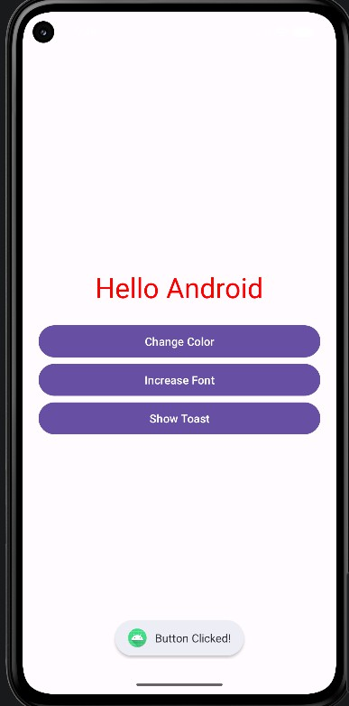
RESULT:
An mobile application is developed in Android studio to change the font and color of the text and display toast message when the user presses the button.

